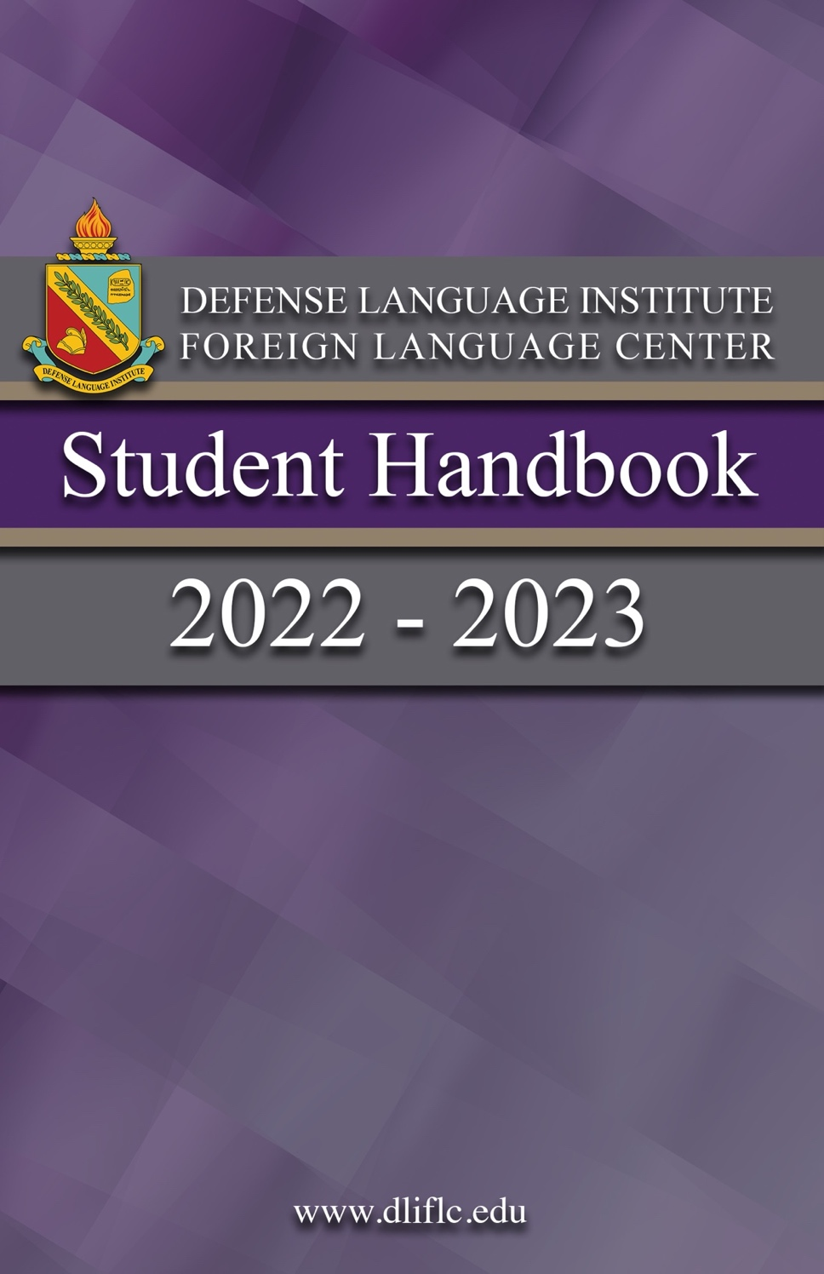

Table of Contents

Mission Statement
Vision Statement
Intent of this Handbook
Student Welcome Letter
Student Services
Religious Support
Academic Calendar
Community Highlights and Off- Post Activities
Basic Course Lengths / Language Codes
Student Responsibilities
Student Leader Responsibilities
Typical Daily Schedule
Testing and Grading
Academic Standards, Feedback and Assistance
Language Learning Strategies
Interagency Language Roundtable (ILR) Scale
Graduation, Diplomas and Awards
Degree Programs
Student Feedback System
Academic Code of Conduct
Student Relationships
Sexual Harassment
Grievance Procedures
Equal Oppotunity
Final Words of Advice
Presidio of Monterey Map
Ord Military Community Map

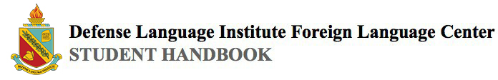
Mission Statement

Defense Language Institute Foreign Language Center (DLIFLC) provides culturally based foreign language education, training, evaluation, and degrees for the Department of Defense (DoD) globally, to afford a comprehensive understanding of the joint operational environment, a competitive edge to our warfighters, and safeguard the national security of the United States.

Vision Statement

To generate and sustain warrior linguists throughout their military journey from apprentice to master.

Intent of this Handbook

This handbook is intended to be a useful source of information for inbound and current students. It is a compilation from many sources across DLIFLC and the Presidio of Monterey (POM).
While we hope this information will be useful, we must acknowledge that there may be inaccuracies due to updates or changes to policy or procedure from what is written here. Please reference all applicable DoD, DLIFLC, and service component directives as needed.

(Back to top)
Student Welcome Letter
You are among 2,500+ students educated each year at DLIFLC. While most students are from the DoD, we also educate students from other federal agencies, state and local governments, and from countries around the globe.

You are entering what will prove to be perhaps the most academically challenging educational program of your life.
Over the next two to 64 weeks, depending on the level of your program and your target language, we expect you to become proficient in a vast array of linguistic and cultural skills to prepare you for your eventual assignment and duties.

Your selection for this demanding program is a reflection of your aptitude, intelligence, and ability, which in itself is praiseworthy. These characteristics, however, only set the stage: you must dedicate yourself and work hard to graduate and be assigned duties based on your linguistic ability. We have faculty and staff ready and eager to assist you. We maintain and upgrade materials, equipment, and facilities toward one end product -- improving your ability to contribute to the national security interests of the United States of America. All we require of you is your time and effort.

Again, welcome to the Institute. We extend to you our best wishes beginning this productive and rewarding learning experience.

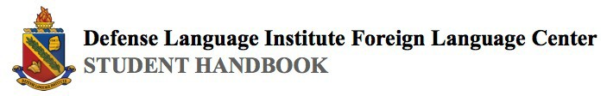
Student Services
For more information about these services, see your service unit representatives.

- Aiso Library, Bldg 617.
The Aiso Library offers a wide range of language related materials. In addition to books, there are maps, games, newspapers, magazines, and computer software in more than 40 languages. The library is designed to enhance your language studies. Hours of operation are: Monday-Thursday 1100-2100 and Friday 0800-1700. The library is closed on weekends.

- Price Fitness Center (PFC), Bldg 842.
This state-of-the-art complex offers a wide range of sporting facilities to include three indoor basketball courts, racquetball courts, weight rooms, aerobic exercise room, saunas and showers. Contact the PFC at 831-242-5557 for the most
up-to-date hours.

- Army Community Services, Bldg 4260 OMC.
Army Community Services provides information and assistance to active duty and retired personnel and their family members. All
U.S. Armed Forces are eligible for this assistance. The services include family counseling, childcare, budget and debt counseling, and food programs for those who qualify. Contact the Army Community Services at 831-242-7660. Hours of operation are: Monday - Thursday 0800-1630, Friday1300-1630. The Army Community Services is closed on weekends.

- Post Exchanges and Commissary.
A small AAFES Exchange is on the POM. A larger one is on the POM Annex (Ft. Ord Military Community or OMC), along with a commissary. The POM Exchange has a barber shop, uniform store, alterations store, dry cleaning, and a food court. Contact the POM exchange at 831-647-9602. Hours of Operation are: Monday – Friday 1000-2000, Saturday and Sunday from 1000-1800. Students can also purchase an array of groceries, clothing, school supplies and barracks goods. Contact the Commissary at 831-242-7668. Hours of operation are: Tuesday through Saturday from 0900-1900, and Sunday from 1000-1800. The Commissary is closed on Mondays.

- Hobson Recreation Center, Bldg 843.
The Hobson Recreation Center is the best place on the POM to hang out with your classmates and have some fun. The center is open to all eligible military service members and their families, DoD civilian employees, and their guests. The Hobson also offers student extracurricular activities and clubs. Contact the Hobson at 831-242-5447. Hours of operation are: Monday - Thursday 1600-2100, Friday 1600-0030, Saturday 0900-0030, and Sunday 0900-2000

Religious Support
POM offers a wide array of spiritual care, including services and clubs. The Religious Support Office provides spiritual readiness for any DOD personnel at POM. Contact: 831-242-5405 or 831-242-5233. You can also coordinate with your unit’s chaplain for any needs you have.

Academic Calendar
- DLIFLC has no set academic calendar because of the continual enrollment and graduation of students. The following list shows the approved student days off from language education.

- Federal Holidays.
The following are federal holidays when DLIFLC does not conduct language instruction.

New Year's Day 1st of January

Martin Luther King Day 3rd Monday in January Presidents Day 3rd Monday in February

Memorial Day Last Monday in May

Juneteenth 19th of June

Independence Day 4th of July

Labor Day 1st Monday in September

Columbus Day 2nd Monday in October

Veterans Day 11th of November

Thanksgiving Day 4th Thursday in November

Christmas 25th of December

(Back to top)

- Training / Resiliency Days.
Designated by the Commandant via annual policy letter, training/resiliency days may be associated with select federal holidays. Military personnel are released to their Service units on training days.

- Holiday Block Leave (HBL).
A two-week break in late December/early January. Students are afforded leave opportunities during this time at the discretion of the applicable Service unit commanders.

- Academic Break.
A one-week academic break may be authorized for language programs with a duration of at least 25 weeks. Programs from 26 to 36 weeks in duration that include HBL are not authorized an academic break.

Community Highlights and Off-Post Activities

- Monterey and Carmel Beaches.
Monterey has a wide array of beaches, including the Monterey State Beach. Visitors can enjoy body-boarding, surfing, picnicking and dog-walking. Another popular beach is the San Carlos Beach, located near the boat launch site and the beginning of Cannery Row.

- Laguna Seca Raceway
Monterey is world-famous for the Laguna Seca raceway. The raceway hosts a variety of events throughout the year, including cycling festivals and charity events, car shows, and, of course, races. Visit their website to get the full calendar of upcoming events.

- Sea Otter Classic
The Sea Otter Classic is an annual cycling festival hosted at the Laguna Seca raceway. Whether you are interested in participating or simply want to spectate and enjoy the food, the festival has something for everyone. Great for military members with children!

- Pebble Beach Pro-AM Golf Tournament
The Pebble Beach Pro-AM Golf Tournament is an annual event with a rich history dating back to the 1930s. Celebrities and athletes
kick-off the first day of the tournament, and the next three days are competitions with professionals and amateurs alike.

- Hiking
Anyone interested in hiking should check out the beautiful state parks and forests surrounding Monterey Bay. One attraction is the

Los Padres National Forest. It is over 2 million acres and contains a wide variety of plant and animal life, including the highly endangered California condor. Another highlight is the Andrew Molera State Park. Visitors can both hike and beach comb the beautiful area.

- Camping
There are many excellent campsites within driving distance of the Presidio. Yosemite is the most famous, with beautiful waterfalls and a huge variety of wildlife. Reservations are typically needed. For something closer to the ocean, consider Big Sur, which hosts a variety of parks and locations to enjoy. Check availability ahead of time and which areas are off-limits for camping. Also, please be aware of the overnight leave policies of your unit.

(Back to top)

Basic Course Lengths/Language Codes
Below are the languages, program lengths, and language codes for the basic language courses. Intermediate and advanced language courses are not listed.

Language | Length (Weeks) | Lang. / School Code
Chinese-Mandarin | 64 | CM
Korean | 64 | KP
Pashtu-Afghan (Pashto) | 64 | PV
Indonesian | 36 | JN
French | 36 | FR
Spanish | 36 | QB
Tagalog | 48 | TA
Russian | 64 | RU
Japanese | 64 | JA
Arabic-Egyptian | 64 | AE
Arabic-Iraqi | 64 | DG
Arabic-Levantine Syrian | 64 | AP
Arabic Modern Standard | 64 | AD
Persian Farsi | 48 | PF

(Back to top)

Student Responsibilities
  - Prepare for class by completing assigned homework and bringing required study materials with you.

  - Attend class every day and actively participate.

  - Preview the next day’s lesson in advance whenever possible.

  - Use your target language at every opportunity, with both professors and classmates, whether in class or after hours.

  - At the end of the day, review what you learned in class.

  - Use your Academic Chain of Command to get any additional assistance you require.

Student Leader Responsibilities
- Serve as class spokesperson - represent class concerns to your teachers/Chief Military Language Instructor (MLI); be a conduit for faculty/school communication with the class.

- Maintain military decorum and high standards of conduct, and work with your teachers/Chief MLI.

- Lead by example - appearance, attitude, & classroom participation.

- Foster teamwork/equal opportunity - everyone deserves dignity and respect.

- Direct and maintain classroom/lab cleanliness.

- Comply with and enforce the Prohibited Relationships policy - report improper relationships to your Chief MLI immediately.

- Motivate classmates whenever possible. Bottom Line: You are critical to the success of your classmates. As a Student Leader, you are a vital, on-the-spot member of our leadership system.

(Back to top)

Typical Daily Schedule
- There are two basic schedules, the only difference being when lunch occurs. Continuing education students use a third schedule.

Schedule Breakdown
Sched A | Hour 1 | Hour 2 | Hour 3 | Lunch | Hour 4 | Hour 5 | Hour 6 | SA*
Start | 0755 | 0855 | 0955 | 1045 | 1200 | 1300 | 1400 | 1500
End | 0845 | 0945 | 1045 | 1200 | 1250 | 1350 | 1450 | 1545
Sched B | Hour 1 | Hour 2 | Hour 3 | Hour 4 | Lunch | Hour 5 | Hour 6 | SA*
Start | 0755 | 0855 | 0955 | 1055 | 1145 | 1300 | 1400 | 1500
End | 0845 | 0945 | 1045 | 1145 | 1300 | 1350 | 1450 | 1545
Cont. Ed. | Hour 1 | Hour 2 | Hour 3 | Hour 4 | Lunch | Hour 5 | Hour 6 | SA*
Start | 0755 | 0855 | 1000 | 1100 | 1150 | 1310 | 1410 | 1500
End | 0845 | 0945 | 1050 | 1150 | 1310 | 1400 | 1500 | 1545
* = Mandatory for Students on Special Assistance or Probation

(Back to top)

- Seventh hour is mandatory for students on special assistance (SA), probation (PB), or as directed by the Office of the Dean (OD).

- Attendance during seventh hour is mandatory until the first major graded event in order to develop adequate study habits, complete homework, and conduct Defense Language Proficiency Test (DLPT) preparations while a faculty member is present.

- In addition to the basic schedule provided here, many service units typically host some form of daily physical training.

Testing and Grading
- Basic Guidelines.
The following are some basic guidelines regarding testing and grading at DLIFLC:

  - Teaching teams will explain to you the policies and procedures for giving and grading tests, quizzes and homework.

  - Criteria for letter grades of each test must be determined before the test is administered. The teaching team must ensure students are informed of the numerical or descriptive criteria for each grade on each test before the test is administered.

  - Subjective grades, such as “classroom participation,” are not assigned or used to determine test or final course grades.

  - Your teachers will report all test, quiz and homework grades and provide feedback to each student within three academic days after a test or quiz is administered or homework is turned in.

- Test Grade Scales.

  - You will receive both letter and numerical grades for each test. The letter grade will determine whether you pass the test.
The cumulative, weighted, numerical grades will equal your grade point average (GPA).

  - The following table represents the relationship of test values and letter grades:

A | 4.0 | B | 3.0 | C | 2.0 | D | 1.0
A- | 3.7 | B- | 2.7 | C- | 1.7 | F | 0.0
B+ | 3.3 | C+ | 2.3 | D+ | 1.3
Note: The following grades will not be assigned: A+, D-, F+, F-.

Academic Standards, Feedback and Assistance
- Standards.
A grade of ‘C’ is the lowest passing grade. You must maintain, over the most recent four weeks of instruction (two weeks for a Category I language), an overall average grade of C or better as well as in each of the major skill areas. The Institute does not assign impression grades, such as "classroom participation."
Teachers may give informal assessments for assigned classroom activities to provide you and your Service unit commanders with feedback on your performance. DLIFLC regulations provide more information on these criteria. Your teaching team, chairperson, Chief MLI or AD can provide you these regulations or information.

- Academic Feedback.
Regardless of your grades, your teaching team will periodically give you feedback on your academic progress. This academic feedback should not be confused with supervisory counseling.
This formative feedback is designed to let you know how you are
progressing and how to improve your language skills. At least once a month, this feedback will be in writing, with the documentation retained in your file.

- Academic Assistance.
Should your grade average in any skill area drop to less than C over the most recent four weeks (two weeks for a Category I
language), or should the teaching team observe performance deficiencies, your teaching team will take several steps to help you.

  - First, the team will formally counsel you -- tell you where you need extra work and what steps to take to improve. You may be placed on special assistance with mandatory tailored instruction.

  - Each tailored instruction session must be conducted with a teacher in the same room with you. Teachers will actively participate in the education. Tailored learning sessions will have no more than three students per teacher. You may receive this small group tailored instruction any time during the day.

  - If your grades continue to decline even after the formal counseling/special assistance/tailored instruction, you will be placed on probation. If you are placed on probation you will meet with your Department Chairperson (and, perhaps, a member of the Office of the Dean) to review the teaching team's recommendations. The teaching team will further tailor a study plan to help you improve in problem areas.

  - Periods of probation will be no less than two weeks, during which time you will receive tailored instruction. By the end of the probationary period, if you do not raise your grades to a minimum of C over a four week period (two weeks for a Category I
language), the teaching team may recommend recycle or disenrollment from the program.

  - Each formal counseling, special assistance, or probation action for academic deficiency MUST be followed by a minimum
of 10 days of tailored instruction. Each formal counseling or probation action must specify your deficiencies, specific actions you must take, and document each tailored instruction session.

Remember: The ultimate responsibility for learning the language rests with the individual! Your teaching team is there to assist you. Take advantage of the help that they can provide.

(Back to top)

Language Learning Strategies
Each person has a preferred learning style. For example, some are visual learners who want to look at new words as they say them. Others are auditory learners who enjoy activities that allow them to listen. For more in-depth training about learning styles and which strategies may work best for you, see your school’s Academic Specialist, your MLI team, or the Student Learning Services Team.

DLIFLC provides methods and resources for all types of learning. The Aiso Library has books, magazines, games, and movies in target languages, as well as quiet places to study. Take advantage of what is provided to you and immerse yourself in the language as much as possible. In addition, be sure to stay on top of current events.

Contact your teaching team if you are having any difficulty during your course. They are there to help.

Your school’s Academic Specialist, Chief MLI, teaching team, and the Student Learning Services Team can give you more information on means to help you succeed in your language program.

(Back to top)

Interagency Language Roundtable (ILR) Scale

LEVEL | FUNCTION/  TASKS | CONTEXT/  TOPICS | ACCURACY
5 | All expected of an educated native speaker (NS) | All subjects | Accepted as an educated NS
4 | Tailor language, counsel, motivate, persuade, negotiate | Wide range of professional needs | Extensive, precise and appropriate
3 | Support opinions, hypothesize, explain, deal with unfamiliar topics | Practical, abstract, special interests | Errors never interfere with communication & rarely disturb
2 | Narrate, describe, give directions | Concrete, real world, factual | Intelligible even if not used to dealing with non-NS
1 | Q&A, create with the language | Everyday survival | Intelligible with effort or practice
0 | Memorized | Random | Unintelligible

Graduation, Diplomas and Awards
- Graduation Criteria.
To receive a DLIFLC Diploma, the student must:

  - Pass all DLIFLC language courses with a grade of “C” or higher.

  - Maintain a cumulative grade point average of 2.0 or higher on all DLIFLC language courses.

  - Achieve the following results on the DLPT:

Basic programs – Level 2 or higher in listening and reading, level 1+ or higher in speaking (L2/R2/S1+).
Intermediate programs – Level 2+ or higher in listening and reading, level 2 or higher in speaking (L2+/R2+/S2).
Advanced programs – Level 3 or higher in listening and reading, level 2+ or higher in speaking (L3/R3/S2+).

- Basic Program Student Recognition.
Special recognition for academic performance is documented on diplomas for basic programs as shown below. The recognition you will receive will depend on your performance on the Proficiency tests (the DLPT).

  - Honors. Achieve a 2+/2+/2 with a 3.2 GPA.
  - High Honors. Achieve a 3/2+/2 or 2+/3/2 with a 3.5 GPA.
  - Highest Honors. Achieve a 3/3/2 with a 3.8 GPA.

- Advanced Program Student Recognition.
Special recognition will also be made for Intermediate and Advanced programs as shown below.

INTERMEDIATE

  - Honors. Achieve a 3/3/2 with a 3.2 GPA.
  - High Honors. Achieve a 3+/3/2 or 3/3+/2 with a 3.5 GPA.
  - Highest Honors. Achieve a 3+/3+/2+ with a 3.8 GPA.

ADVANCED
- Honors. Achieve a 3+/3/2+ or 3/3+/2+ with a 3.2 GPA.
- High Honors. Achieve a 3+/3+/2+ with a 3.5 GPA.
- Highest Honors. Achieve a 3+/4/3 or 4/3+/3 with a 3.8 GPA.

- Awards.
Regardless of your class size, you and your classmates are eligible for several awards that are presented at your graduation ceremony. Those awards include some or all of the following:

  - Commandant's Award:
1. Minimum final grade point average of 3.7; or qualify for Honors
2. Consistent high interest in foreign language study
3. Strong leadership contributions within the military unit, academic classroom, and local community

  - Provost's Award:
- Top 5% of the class (GPA); minimum final grade point average of 3.7 AND qualify for Honors
- Demonstrated classroom leadership and a strong effort to assist fellow classmates

  - General Maxwell D. Taylor Award:
1. Minimum grade point average of 3.7; or qualify for Honors
2. Academic achievement and military performance
3. Epitomize the highest ideals of a military linguist

  - Martin J. Kellogg Award:
1. Minimum final grade point average of 3.7; or qualify for Honors
2. High academic achievement in language training
3. Documented dedicated efforts toward gaining a deeper understanding of a foreign culture

  - Kiwanis Award (Quarterly)
1. Academic achievement
2. Dedicated efforts to gaining a deeper understanding of the applicable foreign culture

  - The Command Sergeant Major’s Award
- Minimum final grade point average of 3.5; and qualify for Honors
2. Military performance to include high NCO/PO ideals and values
3. Strong leadership contributions in the classroom, the military unit, and the local community

  - Donor/faculty book awards:
*Individual schools have established criteria for these awards
(Back to top)

Degree Programs

Associate’s Degrees / Bachelor’s Degrees / College Credits

- DLIFLC is accredited by the Accrediting Commision for Community and Junior Colleges (ACCJC) of the Western Association of Schools and Colleges (WASC) and is recognized by the Council for Higher Education Accreditation and the U.S. Department of Education. Each course at DLIFLC awards a specific number of credits (semester hours) for each semester portion of the course. These vary by language and level of the course. Most basic courses award 15 semester hours of college credit per DLIFLC semester, or 45 hours for the entire three-semester program. To obtain an AA degree in foreign language upon successful completion of the program, one must transfer 15 units (English, math, science, etc.) from another accredited educational institution. Contact the school or Registrar’s Office for details regarding the number of credits needed for your program.

- Students in other than Basic programs are eligible to receive various college credits using their transcripts. Contact the Registrar’s Office for details concerning academic credit for the DLPT.

3. In March 2022, DLIFLC began awarding the Bachelor of Arts degree, either a B.A. in Foreign Language or a B.A. in Russian. The degree requirements are to successfully complete the Basic Course AND either the Intermediate, Advanced, or Defense Threat Reduction Agency (DTRA) Course. The Basic Course Program must be completed in residence at Monterey; the Intermediate or Advanced Course may be completed in Monterey or at one of the Language Training Detachments (LTDs).

For more information on degree plans and college credits, please refer to the DLIFLC General Catalog, available on the website at
https://www.dliflc.edu/resources/publications/general-catalog/

To request a transcript, complete DLIFLC Form 220 (available on the website at www.dliflc.edu/academics/transcripts-records/) and mail, fax, or scan/email to:
EMAIL: transcripts@dliflc.edu
FAX: 831-242-5146 / DSN 768-5146
TEL: 831-242-6455 / DSN 768-6455

Defense Language Institute Foreign Language Center
ATFL-ASD-DA
(Attn: Registrar’s Office)
Presidio of Monterey, CA 93944-5006

Student Feedback System

- The feedback you give the Institute on language instruction and other issues that affect your studies is a valuable management tool. We welcome your suggestions to improve our language programs and administrative support.

- How to provide feedback.

  - On-going dialog with teaching teams. Let them know each day what worked for you or bring areas of concern to the attention of your teachers. This will give the team immediate feedback on their efforts and may alleviate problems on the spot.

  - Interim Student Feedback Forms. Periodically during the instructional program, you will have the opportunity to provide written feedback that is collected and consolidated by your student leaders and reviewed by teachers, chairpersons and the Office of the Dean.

  - Student Leader Meetings. Discuss your problems and concerns with your Student Leaders. They meet with the Office of the Dean once a month to talk about various topics.

  - Sensing Sessions. Periodic student meetings with senior school leadership to allow you the opportunity to provide open, timely feedback.

  - End of Course Student Questionnaires (ESQ). You will be asked to complete this in-depth questionnaire near the end of your training. The ESQ is the Institute's feedback procedures to gather your comments and suggestions.

  - DLIFLC Student Senate. The DLIFLC Student Senate is the primary organization of shared student governance at DLIFLC, representing the collective voice of students across all service branches and language courses. Student senators adhere to a standard of excellence and strive to uphold the values of the student body. Using student feedback, our mission is to collaborate with the Command Group to advocate for improvements that enhance both academic and unit success. They can be contacted at dlistusen@dliflc.edu.

- Feedback is for the purposes of improving instruction, administrative procedures, your school, or complimenting the areas or teachers that deserve accolades. To work best, it will help if you provide complete feedback. Suggestions on how to improve a deficiency are just as important as calling the deficiency to our attention. Compliments should mention the teacher, the particular class, and what made the instruction worthy of your praise.

(Back to top)

Academic Code Of Conduct

- Honesty and integrity are expected of all people associated with the Institute whether military or civilian, student or staff.

- Academic misconduct includes but is not limited to cheating, forgery, plagiarism, fabrication, theft of instructional material or tests, alteration of grades, or failing to report suspected misconduct.

- Students are responsible to ensure they avoid any form of academic misconduct. Academic misconduct will result in dis- enrollment from the program and could lead to punishment under the Uniform Code of Military Justice.

- Students are not allowed to use any reference materials during tests in or outside the regular classroom, unless specifically authorized. Each student must ensure that his/her immediate work area is clear of any such materials. Bringing them, unless specifically authorized, may be construed as cheating.

- All tests, written or oral, are FOR OFFICIAL USE ONLY (FOUO). The unauthorized discussion or possession of any part of any test by a student is a violation of Article 92 of the UCMJ.
- Report suspected academic misconduct immediately. Anyone suspected of academic misconduct will report to the Office of the Dean (OD). The OD will ensure an investigation is initiated. The service unit investigates disciplinary infractions and takes appropriate action based on findings. Academic Misconduct, regardless of form, is not accepted.

Student Relationships

Non-professional relationship: Any personal interaction between
individuals that is not necessary to the performance of their official duties, or part of an officially sanctioned athletic or social function. Non-professional relationships between the following personnel are prohibited:

- Initial Entry Training (IET) students and Service equivalents.

  - May not form non-professional relationships with any officer, noncommissioned officer, or school staff member in their language class or unit.

  - May not form non-professional relationships with any permanent party civilian or military staff member.

  - May not have Officer or NCO visitors to their barracks room, without the authorization of their company, unit, or higher command authority.
  - May not visit the barracks room or home of an Officer or NCO without the authorization of their company, unit, or higher command authority.

  - Personnel in the grade of E-3 and below may not form non-professional relationships with personnel of greatly superior rank or grade (more than two grades) unless exceptional circumstances apply. If military members believe exceptional circumstances apply, they must bring it to the attention of their unit chain of command immediately.

- Enlisted Careerists.

E-1 through E-4 careerist and other service equivalents: All of the restrictions cited in 1 above apply, excluding letters b, c, and d.

- Officer/NCO Students.

  - May not form non-professional relationships with IET students and other service equivalents in their language class or unit.

  - May not form non-professional relationships with school staff in their language school, or classroom/unit chain of command.

  - May not have IET visitors to their quarters without the authorization of their company, unit, or higher command authority.

  - DLIFLC and POM staff members (military/civilian) who are involved in training or evaluation activities may not form non-professional relationships with DLIFLC and POM students.

Note: This policy is punitive in nature. Violations of this policy may subject military members to punishment under the Uniform
Code of Military Justice or other appropriate administrative action. Civilian personnel are subject to disciplinary action under applicable personnel regulations.

Sexual Harassment

Sexual harassment is defined as (1) influencing, offering to
influence, or threatening the career, pay, or job of another person in exchange for sexual favors; or (2) deliberate or repeated offensive comments, gestures or physical contact of a sexual nature in a work or duty-related environment.

Sexual harassment is unacceptable behavior. The Institute will not tolerate it.

Review this policy in full at your Service unit's administration section. Each Service's policy may vary slightly.

DLIFLC SHARP (Sexual Harassment/Assault Response and Prevention Program) can be contacted at 831-915-2351 or via the DoD Hotline at 877-995-5247.

Grievance Procedures

Use of the chain-of-command is encouraged, as DLIFLC is a military
organization. However, additional channels exist that facilitate
institutional improvement. Specifically, Garrison support systems have Interactive Customer feedback links that encourage feedback. Interim and Exit Student Questionnaires facilitate communication of student concerns. Other mechanisms include the Chaplain's Office and Inspector General's Office.

(Back to top)

Equal Opportunity

Our nation’s diversity is one of its most enduring strengths. A
workplace free from unlawful discrimination and reflective of our nation’s diversity is central to maintaining a mission-ready
workforce. It is essential we maintain an environment free of harassment, including verbal or physical conduct that creates an intimidating or hostile work environment for any individual.

We are fully aware that achieving these goals will require both a sincere commitment to and active participation in our Equal Opportunity efforts. That is our expectation of our leaders, managers, supervisors, and employees. Our office is fully committed to ensuring all personnel have the maximum opportunity for selection, advancement, retention, and recognition.

Therefore, we charge our leaders to empower Service Members with the means necessary to reach their full potential. We also expect each Service Member to demonstrate his or her talents and cooperation in helping our leaders meet this expectation. DLIFLC Equal Opportunity can be contacted at 831-242-4431, or via hotline at 831-582-7612.

Final Words Of Advice
To successfully complete your target language program, you must take personal responsibility for learning. Study and work hard daily -- starting the very first day and throughout the entire program. Remember that you are not alone, and that help is available if needed, all you have to do is ask. Good luck!

(Back to top)

Presidio of Monterey Map
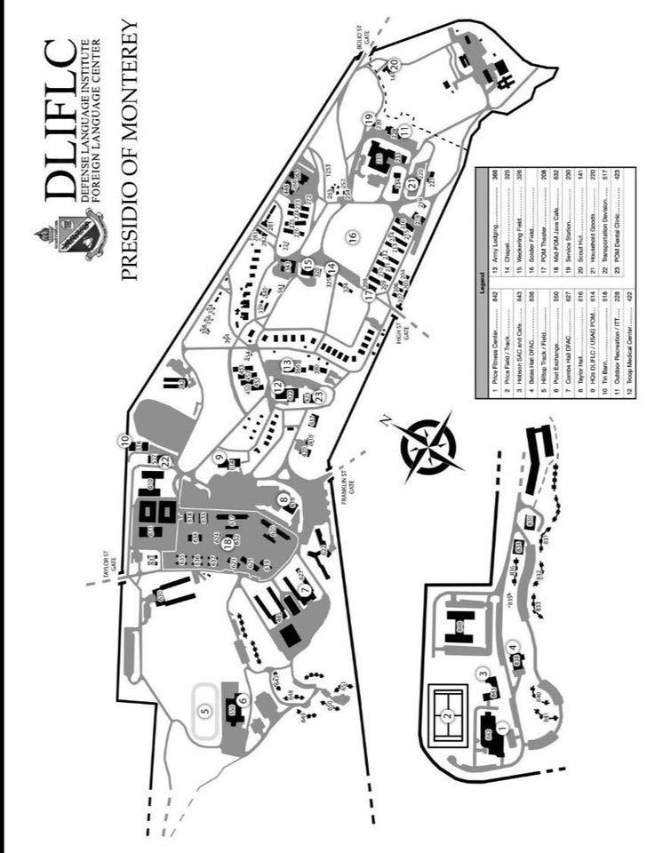

Ord Military Community Map
